FORK WREATH
2 brushes, medium, small, plastic fork, sharpened match (for sqraffito),
Colors: Lime Ricky, Happy go Lucky, Rockin Red, Red Rover, Blue Heaven, What a Yolk.

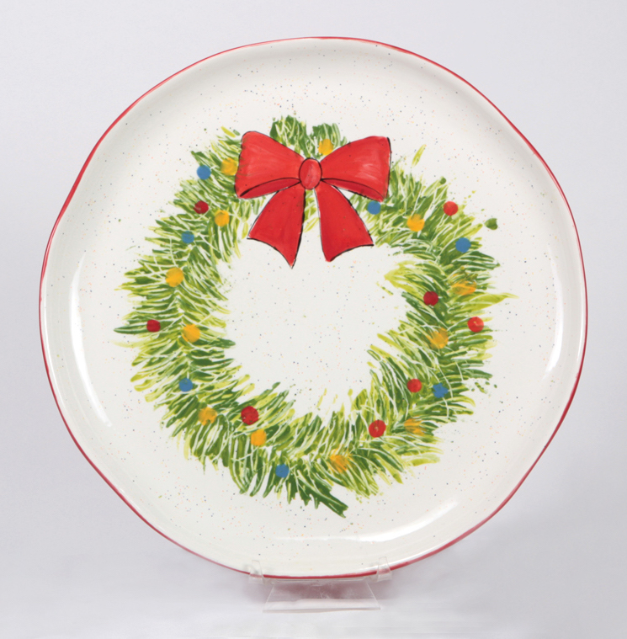
- The plate is already coated with 3 coats of Speckled White.
- Transfer the pattern onto the plate using the Clay Carbon Transfer paper. The greenery is for placement more than exact detail.
- On a palette pour the size of a silver dollar of the following colors: Light Green & Dark Green.
- You will now paint the greenery with a fork. Dip the fork into LIGHT GREEN. Press and drag the color from inside of the wreath to the outside going all the way around the wreath.
- Repeat the process with Dark Green to fill in the branches of the wreath and repeat the process. Overlap the LIGHT GREEN, but do not cover entirely.
- Sgraffito in lines on the wreath with the sharpened match to mimic the needles. Periodically, cross over the lines for visual interest.
- Bow: Use the smaller brush and apply 2-3 coats of Rockin Red to the bow. Use RED ROVER (BURGUNDY COLOR) to darken the shadow areas on the bow.
- Use the DETAIL BRUSH to outline the bow.
- Using the eraser end of a pencil, dip the eraser into the following colors and dot the color on the wreath to mimic bulbs. What a Yolk Yellow, Blue Heaven, Rockin Red

BRING IT TO THE STUDIO FOR GLAZING AND KILN-FIRING

